Computer Science

Project

Name: Ashwath John C.

Class: XII

**Acknowledgment**

I wish to record my indebtedness and thankfulness to all those who helped me prepare this project successfully. I would like to take this opportunity to thank them.

First and foremost, I would thank God for helping me complete this project. Then I would like to thank my school, Gulf Indian School and our principal madam, Mrs. Shyamala Divakaran for providing me an opportunity to present this project “Hotel Management System”.

I would also like to thank my teacher, Mr. Facin Mathai for providing critical inputs in the preparation of this program and report.

Finally, I would like to extend my sincere gratitude to my family and friends who have been helpful in preparing and presenting the project.

Index

|  |  |  |
| --- | --- | --- |
| **Serial No:** | **Topic** | **Page No:** |
| 1 | Acknowledgment | 2 |
| 2 | Introduction | 4 |
| 3 | User Manual | 5 |
| 4 | Python Program | 6 |
| 5 | Output | 20 |

Project Outline

Introduction

**Hotel Management**

Hotel management involves the management of anything that’s related to the hotel industry. If you want to gain a foothold in this business, you will need to learn about all the techniques of managing a hotel business including marketing, hotel administration, catering management, housekeeping, and accounts.

A core aspect of hotel management is to manage your inventory.

Effective inventory management for hotels involves both creating and managing demand, and maximising returns. The investment backing a hotel is tied up in its rooms and the returns can only be gained from selling those rooms optimally.

In the program designed for “Hotel Management System” all data is stored in a single binary file “crownplaza”. The user can enter his/her details to the program. The program can display, add and delete details of the customer.

User Manual

The program “Hotel Management System” aims to make staff and customer interaction with various divisions off the hotel more simple and ease the process of acquiring information regarding accommodation and services of the Hotel.

The system can be accessed by the user to:

*Display Room Number

*Calculate Room Rent

*Calculate Restaurant Bill

*Calculate Laundry Bill

*Calculate Game Bill

To access these information the user has to:

*Enter user details

*Provide details of services used

Python Program

#************** Welcome********************#

#**************** Crown Plaza******************#

import random

import pickle

import os

class hotelfarecal:

def __init__(self,rt='',s=0,p=0,r=0,t=0,a=1800,name='',address='',cindate='',coutdate='',rno=random.randint(1,250)):

print ("\n\n*****WELCOME TO CROWN PLAZA*****\n")

self.rt=rt

self.r=r

self.t=t

self.p=p

self.s=s

self.a=a

self.name=name

self.address=address

self.cindate=cindate

self.coutdate=coutdate

self.rno=rno

def inputdata(self):

with open('crownplaza.dat','wb') as fileob:

for i in range(1):

name=input("\nEnter your name:")

address=input("\nEnter your address:")

cindate=input("\nEnter your check in date:")

coutdate=input("\nEnter your checkout date:")

print("Your room no.:",self.rno,"\n")

cpdict={'name':name,'address':address,'checkindate':cindate,'checkoutdate':coutdate}

pickle.dump(cpdict,fileob)

print('Record Added into the file')

def roomrent(self):

print ("We have the following rooms for you:-")

print ("1. type A---->rs 6000 PN\-")

print ("2. type B---->rs 5000 PN\-")

print ("3. type C---->rs 4000 PN\-")

print ("4. type D---->rs 3000 PN\-")

x=int(input("Enter Your Choice Please->"))

n=int(input("For How Many Nights Did You Stay:"))

if(x==1):

print ("you have opted room type A")

self.s=6000*n

elif (x==2):

print ("you have opted room type B")

self.s=5000*n

elif (x==3):

print ("you have opted room type C")

self.s=4000*n

elif (x==4):

print ("you have opted room type D")

self.s=3000*n

else:

print ("please choose a room")

print ("your room rent is =",self.s,"\n")

def restaurentbill(self):

print("*****RESTAURANT MENU*****")

print("\n""1.Water----->Rs20""\n","2.Tea----->Rs10""\n","3.Breakfast combo--->Rs90""\n","4.Lunch---->Rs110""\n","5.Dinner--->Rs150""\n","6.Exit""\n")

while (1):

c=int(input("Enter your choice:"))

if (c==1):

d=int(input("Enter the quantity:"))

self.r=self.r+20*d

elif (c==2):

d=int(input("Enter the quantity:"))

self.r=self.r+10*d

elif (c==3):

d=int(input("Enter the quantity:"))

self.r=self.r+90*d

elif (c==4):

d=int(input("Enter the quantity:"))

self.r=self.r+110*d

elif (c==5):

d=int(input("Enter the quantity:"))

self.r=self.r+150*d

elif (c==6):

break;

else:

print("Invalid option")

print ("Total food Cost=Rs",self.r,"\n")

def laundrybill(self):

print ("******LAUNDRY LIST*******")

print ("\n""1.Shorts----->Rs3""\n","2.Trousers----->Rs4""\n","3.Shirt--->Rs5""\n","4.Jeans---->Rs6""\n","5.Girlsuit--->Rs8""\n","6.Exit""\n")

while (1):

e=int(input("Enter your choice:"))

if (e==1):

f=int(input("Enter the quantity:"))

self.t=self.t+3*f

elif (e==2):

f=int(input("Enter the quantity:"))

self.t=self.t+4*f

elif (e==3):

f=int(input("Enter the quantity:"))

self.t=self.t+5*f

elif (e==4):

f=int(input("Enter the quantity:"))

self.t=self.t+6*f

elif (e==5):

f=int(input("Enter the quantity:"))

self.t=self.t+8*f

elif (e==6):

break;

else:

print ("Invalid option")

print ("Total Laundary Cost=Rs",self.t,"\n")

def gamebill(self):

print ("******GAME LIST*******")

print ("\n""1.Table tennis----->Rs60""\n","2.Bowling----->Rs80""\n","3.Snooker--->Rs70""\n","4.Video games---->Rs90""\n","5.Pool--->Rs50==6""\n","6.Exit""\n")

while (1):

g=int(input("Enter your choice:"))

if (g==1):

h=int(input("No. of hours:"))

self.p=self.p+60*h

elif (g==2):

h=int(input("No. of hours:"))

self.p=self.p+80*h

elif (g==3):

h=int(input("No. of hours:"))

self.p=self.p+70*h

elif (g==4):

h=int(input("No. of hours:"))

self.p=self.p+90*h

elif (g==5):

h=int(input("No. of hours:"))

self.p=self.p+50*h

elif (g==6):

break;

else:

print ("Invalid option")

print ("Total Game Bill=Rs",self.p,"\n")

def display(self):

print ("******HOTEL BILL******")

print ("Customer details:")

print ("Customer name:",self.name)

print ("Customer address:",self.address)

print ("Check in date:",self.cindate)

print ("Check out date",self.coutdate)

print ("Room no.",self.rno)

print ("Your Room rent is:",self.s)

print ("Your Food bill is:",self.r)

print ("Your Laundary bill is:",self.t)

print ("Your Game bill is:",self.p)

self.rt=self.s+self.t+self.p+self.r

print ("Your sub total bill is:",self.rt)

print ("Additional Service Charges is",self.a)

print ("Your Grand Total bill is:",self.rt+self.a,"\n")

self.rno+=1

def delete(self):

with open('crownplaza.dat','rb')as fileob1:

with open('record.dat','wb')as fileob2:

found=0

nm=input("Enter Name of Customer whose record is to be Deleted:")

while True:

try:

cpdict=pickle.load(fileob1)

if (cpdict['name'])==nm:

pickle.dump(cpdict,fileob2)

print("Record Deleted")

found=1

except EOFError:

break

if found==0:

print('No customer with such room number is found')

os.remove('crownplaza.dat')

os.rename('record.dat','crownplaza.dat')

def main():

a=hotelfarecal()

while (1):

print("1.Enter Customer Data")

print("2.Calculate Room Rent")

print("3.Calculate Restaurant Bill")

print("4.Calculate Laundry Bill")

print("5.Calculate Game Bill")

print("6.Show Total Cost")

print("7.Delete")

print("8.EXITING")

b=int(input("\nEnter your choice:"))

if (b==1):

a.inputdata()

if (b==2):

a.roomrent()

if (b==3):

a.restaurentbill()

if (b==4):

a.laundrybill()

if (b==5):

a.gamebill()

if (b==6):

a.display()

if (b==7):

a.delete()

if (b==8):

quit()

main()

Output

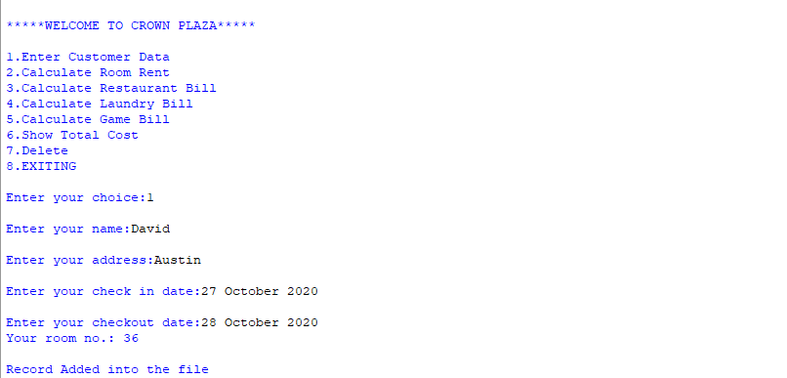1.Enter Details for Customer Data and Room Number

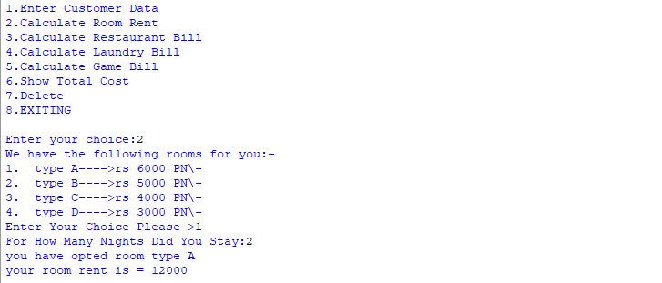2.Enter data to calculate room rent

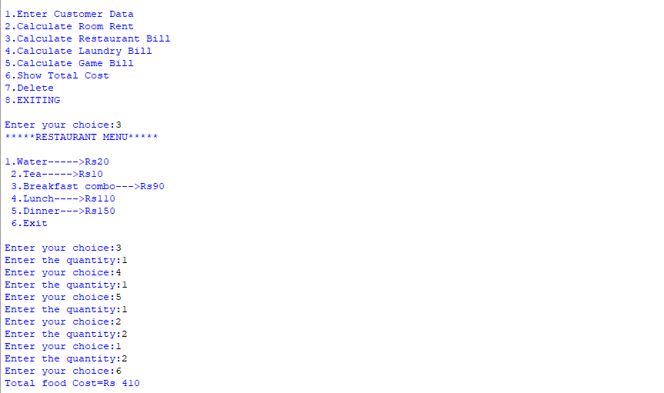3.Enter data to calculate Restaurant Bill

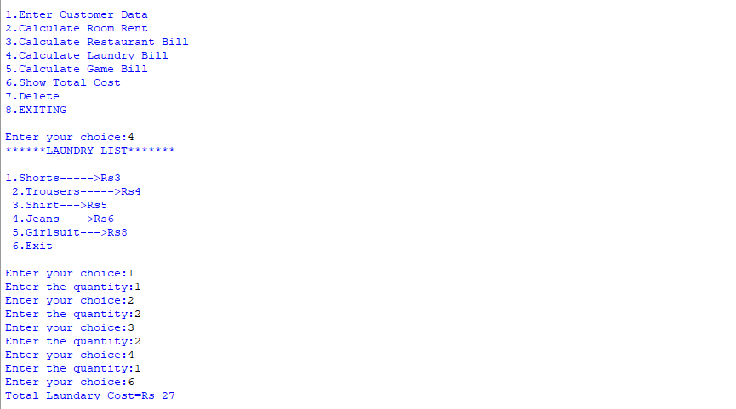4.Enter data to calculate Laundry Bill

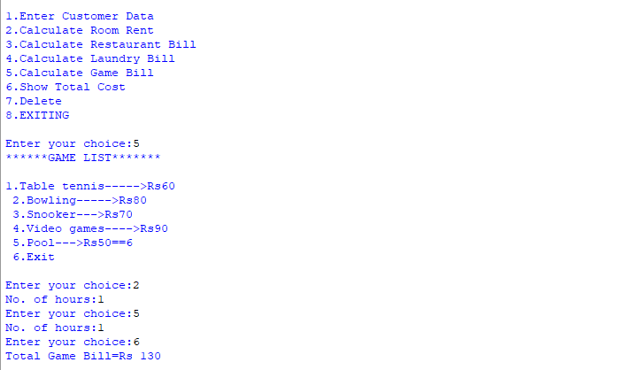5.Enter data to calculate Game Bill

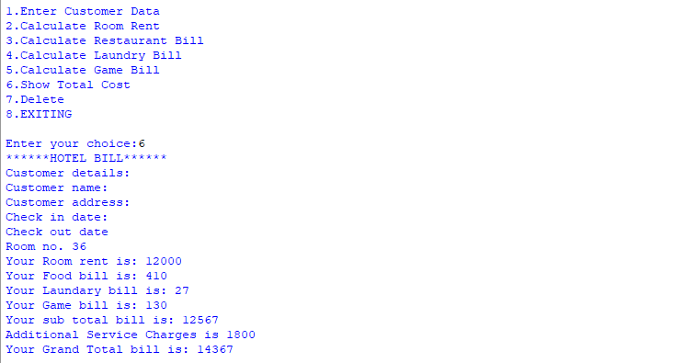

6.Calculate Total Payment of the Customer

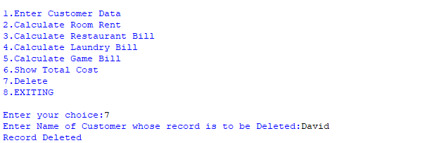7. Delete the Record of A Customer